MOGNO micro-CT results – Well 861 (specimens were made from reserved pieces from standard 1.5” in diameter plugs) – a total of 10 specimens CT.
> Sample 6mm in diameter: F2870H.
> Sample 2.5 mm in diameter: F2829V, F2830H, F2852H, F2854H, F2859H, F2880H, F2910H, F2911V, F2935H.
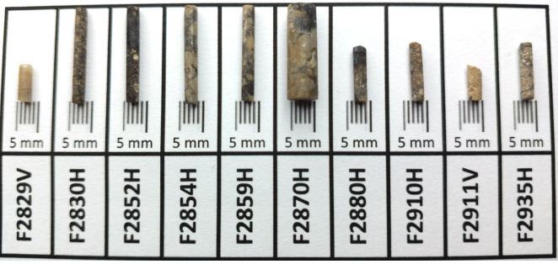
Digital Image Methodology: 1) Evaluate original µCT data and convert to 8 bit gray scale. 2) Pre-processing data before segmentation: a)Evaluate brightness & contrast and suitable filters to reduce noise and artifacts; b) Main gray level (brightness) adjustments: enhance contrast, flickering correction, gradient correction, Gaussian correction; c) Main image filters: Mean, Gaussian Blur; c) CT filter: Ring artifact removal. 3) Image segmentation: multithreshold (pores, solid1, solid2) – Automatic algorithm (Otsu) for pores, and solids of the matrix analysis guided by the interpreter. 4) Identify pores and properties: area, diameter, perimeter, aspect ratio, specific surface, etc.

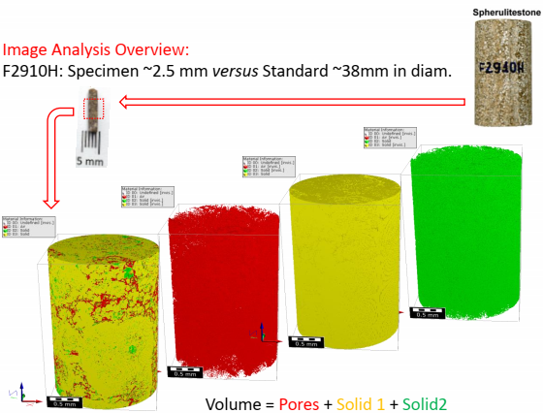

Summary of the results about the image pores detected by the CT images:
Micro CT (sample ~6 mm in diameter) | F2870H(6mm) |  |  |  |  |  |  |  |  | Most significance
Detected Minimun pore area (µm²) | 177.53 |  |  |  |  |  |  |  |  | 177.5305855
Detected Maximun pore area (µm²) | 188674 |  |  |  |  |  |  |  |  | 188673.6683
Detected Maximun pore area (mm²) | 0.188674 |  |  |  |  |  |  |  |  | 0.188673668
Detected Minimun pore diameter (µm) | 15.03 |  |  |  |  |  |  |  |  | 15.03459217
Detected Maximun pore diameter (µm) | 490.13 |  |  |  |  |  |  |  |  | 490.1293457
Detected Maximun pore diameter (mm) | 0.49013 |  |  |  |  |  |  |  |  | 0.490129346
Micro CT (sample ~2.5 mm in diameter) | F2829V | F2830H | F2852H | F2854H | F2859H | F2880H | F2910H | F2911V | F2935H | Most significance
Detected Minimun pore area (µm²) | 28.62 | 22.98 | 25.82 | 28.62 | 25.82 | 25.82 | 25.82 | 25.82 | 25.82 | 22.98
Detected Maximun pore area (µm²) | 2726 | 21536 | 47269 | 342082 | 173393 | 280403 | 2982101 | 705066 | 1052435 | 2982101.252
Detected Maximun pore area (mm²) | 0.002726 | 0.021536 | 0.047269 | 0.342082 | 0.173393 | 0.280403 | 2.982101 | 0.705066 | 1.052435 | 2.98
Detected Minimun pore diameter (µm) | 6.04 | 5.41 | 5.73 | 6.04 | 5.73 | 5.73 | 5.73 | 5.73 | 5.73 | 5.41
Detected Maximun pore diameter (µm) | 58.92 | 165.59 | 245.32 | 659.96 | 469.86 | 597.51 | 1948.57 | 947.48 | 58.92 | 1948.57
Detected Maximun pore diameter (mm) | 0.05892 | 0.16559 | 0.24532 | 0.65996 | 0.46986 | 0.59751 | 1.94857 | 0.94748 | 0.05892 | 1.95
Ps.: The pores were detected by the minimum of 2 voxels from the CT images.

